

**Independent University, Bangladesh**

**Department of Computer Science & Engineering**

**CSE 307: System Analysis and Design**

**Summer 2022**

**Term Project**



**HornPolice**

*A system that ensures a peaceful environment*

|  |  |
| --- | --- |
| Name | ID |
| Azwad Fawad Hasan | 2020222 |
| Tayaba Sultana Hossain | 1830420 |
| Tasnia Tabassum Oishee | 1910040 |

**Table of Contents**

Section 1: 3

1. Introduction 3

2. History leading to project request 3

3. Problems, Opportunities 3

4. Project Goals and Objectives 4

Section 2: 4

5. Product Description 4

6. System Context diagram 5

7. Hardware detail (Include Rich Picture) 5

8. Key Technical Features of Software 6

Section 3: 6

9. Information Gathering methods (At least three methods) 6

10. Major functionalities offered by the system 9

12. Normal and Alternate Scenarios 10

13. Functional Requirements: 13

Non Functional Requirements: 14

Section 4: 14

14. Entity Relationship Diagram 14

15. Logical Data Flow Diagram 15

16. Physical Data Flow Diagram 17

17. Activity Diagrams 20

18. Sequence Diagrams 26

19. Communication Diagrams 29

20. Class diagrams 30

21. State-chart Diagrams 32

22. CRUD Matrix 34

Section 5: 36

23. Structure English pseudo code for the system 36

25. Prototype the user interface 39

# Section 1:

## 1. Introduction

HornPolice is a system that would help in reducing sound pollution and bring out a favorable environment. The main objective of the system is to charge drivers if they surpass a specific number of horns so that they do not use horns unnecessarily. The system is installed in the cars and every car must be registered into the system so that the purpose can be carried out efficiently. The documents of car registration and the license of drivers, car owners are verified and they would have an option to see if their documents have been approved or not. Moreover, the ownership of an existing car can be changed if someone sells their car. In that case, the documents need to be verified again which can be viewed by the car owner. The system requires the bank account number of the car owners so that they can be charged and they would be given a due date by which they need to pay. If payment is not made by the due date, the system notifies the user that their car would be taken away in 4 days.

## 2. History leading to project request

The most populous country in the world, according to some estimates, is Bangladesh. It began with noise pollution and has grown into a major issue. People find the constant loudness of the cars to be annoying.

In some places, there are numerous sign poles warning against using horns. But maintaining every sector in a city is not that simple. With that in mind, this method may serve as a means of ensuring environmental harmony for all. Nowadays, drivers are not as cautious while driving and frequently honk their horns at other vehicles or pedestrians. As a result, there are more accidents. So, if we limit the availability of giving horns, they can only be used when essential.

# 3. Problems, Opportunities

***Problems and Solutions:***

|  |  |
| --- | --- |
| Problems | Solution |
| Excessive sound pollution causes environmental and health distortion. | Before the automobile starts, the program should begin counting the number of horns it will blow, and it should continue doing so until it hits the limit, which should not be fewer than 10. This is just so it can be considered an obligatory requirement. |
| Patients suffer from the negative effects of all these sound pollution. Although it is forbidden to blow horns on any roadways close to hospitals, people nonetheless do it because they are not paying attention. | Unique limitations on the amount deducted increased when around hospitals such that persons are being sufficiently mindful of the environment and their lives, too. |
| Sound pollution near schools | The amount deducted will increase when vehicles are near schools so that excessive sound pollution is avoided. |
| The dependent variable distance will be taken into account. | It will determine the cost for extending the limit based on the kilometers traveled. |

***Opportunities:***

* The system will reduce the charge if the car departs from a place and travels no more than 500 meters.
* If someone goes over the limit after the trip is over, their bank account will be charged.
* The amount that will be taken away from them needs to be increased significantly to encourage people to live responsibly and protect the environment.
* Government can use the data to research how much the reduction of sound pollution is before and after implementing the system.

# 4. Project Goals and Objectives

This system has a very clear objective. This system is an attempt to educate those responsible for environmental pollution about the growing problem of sound pollution. The system ensures a successful method of reducing the number of drivers that beep their horns practically constantly without cause. It will be built and changed in such a way that if the drivers start the car and blow the horn more than the permitted number of times, it will begin gradually charging them and bill them after they stop the car. This structure will be altered to accommodate all modes of transportation and systems, ensuring that they remain fixed to never honk their horns.

# Section 2:

# 5. Product Description

**a. Product Summary**

A better standard of living will need the adoption of this worldwide system. The systems’ major goal is to ensure that everyone will keep the peace in the nation. If more people use it, there will be significantly reduced noise pollution in the streets that are lined with homes, hospitals, and educational institutions. Moreover, the system would help in future research about sound pollution in Bangladesh.

**b. Product Stakeholders:**

* Drivers
* Car owners
* Government
* Bank

# 6. System Context diagram

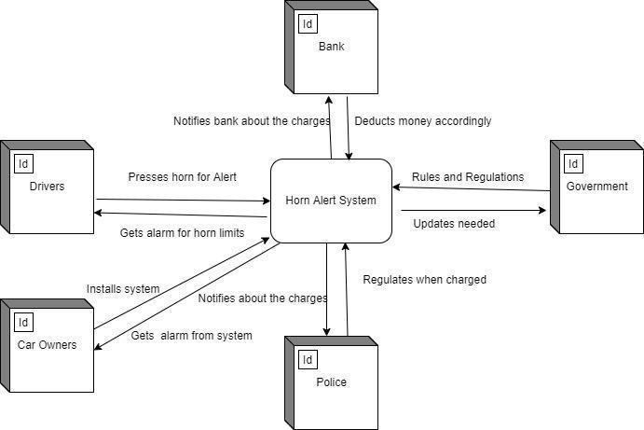

# 7. Hardware detail (Include Rich Picture)

**Frontend:**

* Smartphone, laptop, PC or tablet.
* Internet connection capable of smooth browsing experience.
* A Web Browser or an app (Android/iOS)

**Backend:**

* Servers capable of handling at least 1000 users concurrently hosted by a cloud service provider.
* At least 200MB of storage allocated per user.
* A relational database e.g MySQL, sqlite, etc.
* A language that is capable of handling thousands of requests every second (e.g. C++, Python, Java, etc).

**Rich Picture:**

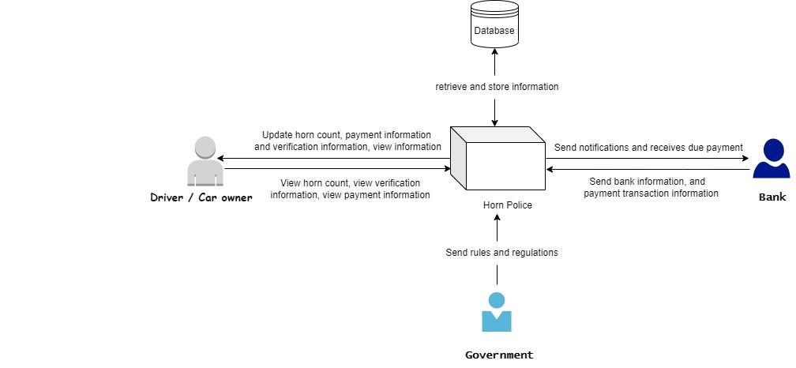

# 8. Key Technical Features of Software

* JavaScript is the main frontend language since it is compatible with Android and iOS.
* Backend uses Django for ease of maintainability.
* User authentication code system to ensure sensitive data is not revealed.
* OTP 2FA used for signup/login.

# Section 3:

# 9. Information Gathering methods (At least three methods)

* *Questionnaires*
* *Interview*
* *JAD (Joint Application Development)*

Analyzing the project objectives and goals it has come to a compelling state to follow the steps of the project view. As our project is an installing system, the illustrative sample of the user is quite closed. Therefore to gather all the necessary information for this project, following methods have been used.

**Questionnaires:**

Before initiating the project based works, questionnaires are the way of gathering preparatory information about the needs and requirements. As the project consists of a very small number of users so the process is going to be physical rather than emailing a soft copy or documental form.

|  |
| --- |
| ***Are you an owner of a vehicle?*** |
| * YES |
| * No |
|  |
| ***If yes, what kind of vehicle do you own?*** |
| * Car |
| * Bus |
| * Pick-up Van |
| * Motor Bike |
| * Truck |
| * Auto Rickshaw |
|  |
| ***How much money do you spend on your vehicle per month?*** |
| * Tk 6000- 4000 |
| * Tk 3000- 2000 |
| * Tk 1500-1000 |
| * Tk 1000-800 |
| * Tk 800-500 |
|  |
| ***Do you agree that 90% of the sound pollution is caused by motor vehicles on the road?*** |
| * Agree |
| * Strongly Agree |
| * Disagree |
| ***To what extent do you think the new noise reduction system is helpful for the environment? On a scale of 1-10.*** |

|  |
| --- |
| ***How well will you maintain the rules of the system?*** |
| * Considerably |
| * Slightly |
|  |
| ***If not, do you drive for any service transportation platform? (Like: Uber, Pathao, Obhai etc)*** |
| * Uber |
| * Pathao |
| * Obhai |
| * Shohoz |

**Interview:**

Various viewpoints were recorded with different perspectives while our interview was conducted in an open setting. The questions we pose are entirely impartial, even though our system will deal with the public, citizens, and transportations. Starting with members of the working class and moving on to those who live along the street, we will be interviewing city residents- the people who live in the homes near the streets and major thoroughfares. The concerns and viewpoints expressed by hospital staff on behalf of their patients will also be noted. Interviews will be conducted with both the automobile owners and the drivers.

Interview Questions with Public:

|  |
| --- |
| 1. How is the noise pollution in the cities of Bangladesh? Especially Dhaka city. |
| 1. How long have you been living in the cities? |
| 1. How much do you think sound pollution is affecting health? |
| 1. Do you believe that there should be limits in the horns of the vehicles? |
| 1. What do you think about the new system? |
| 1. Do you agree that people will maintain the rules? |
| 1. Do you think that this system will reduce noise pollution? |

Interview Questions with Vehicle owners?

|  |
| --- |
| 1. Do you believe that vehicle noise is one of the main causes for sound pollution? |
| 1. How long have you been a car owner? |
| 1. What do you think will help reduce the contamination? |
| 1. What do you think about the new system? |
| 1. Will you maintain all the rules of the system? |

Interview Questions with drivers?

|  |
| --- |
| 1. How long have you been a vehicle driver? |
| 1. Do you think one of the major reasons behind sound pollution is due to the horn of vehicles? |
| 1. What are the possible ways to reduce this? |
| 1. What do you think about the new system? |
| 1. Will the money reduction bring awareness to a limited number of horns? |

**JAD:**

Using the JAD technique, the analyst can perform requirement analysis and jointly design the user interface with a group of users. We have reached a stage where the requirements are satisfied for the use of JAD support after multiple iterations. All the features and requirements have been compiled by the IS analyst, users, and observers.

Due to the high number of users in our project who are of the same type, there will be a management of satisfaction at all working levels. The budget and cost, the system's dependability, the amount of people required working on it, and certain future difficulties were all reviewed in accordance with the requirements. All of the functional and non-functional needs were met while keeping everything in mind and the next course of action was chosen. The required case study and use case diagrams were created for the final prototype.

# 10. Major functionalities offered by the system

* Charges car owners based on the amount of horn numbers they have exceeded from the honking limit.
* Verifies car documents provided.
* Verifies information about drivers.
* Signup, Login of users.
* Allows transfer of ownership of vehicles.
* Validates transfer of ownership of vehicles.
* Charges more while passing through some specific area.

**11. Use case diagram**

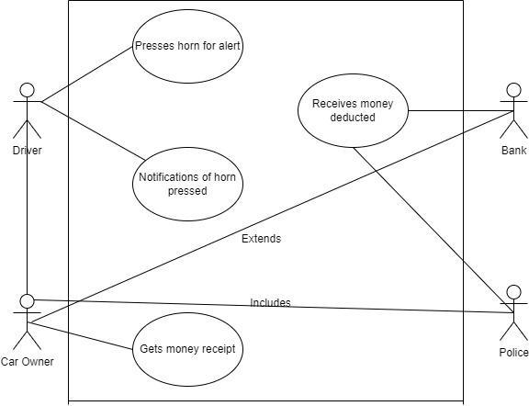

# 12. Normal and Alternate Scenarios

|  |  |
| --- | --- |
| User case name: Billing payable amount | Unique ID: |
| Area: System screen |  |
| Actor(s): System, Driver, Car Owner |  |
| Stakeholder: Bank, Government |  |
| Description: The total money deducted after the car exceeds the limit. |  |
| Trigger event: An amount of money will be shown on the screen. |  |
| Trigger type: Horn count |  |
| Steps performed | Information for steps |
| 1. After the vehicle reaches the limit, the counter will start adding money to be deducted.  2. The total money will be summed up and shown on the screen. | 1. The driver needs to cross the limit and after that the counter will start counting.  2. The car needs to stop first and then the system will show the total amount. |
| Preconditions: The system needs to be installed. |  |
| Post conditions: The system can make a total amount of money to be deducted. |  |
| Assumptions: Payable amount with due date. |  |
| Success guarantee: A correct amount of money will be shown. |  |
| Minimum guarantee: Counting will be multiplied with the deduction rate. |  |
| Requirements met: Total money with rewards. |  |
| Outstanding issues: Will the extra charge for the exceptions be shown? |  |
| Alternative scenario: User will get notification from the bank. |  |

|  |  |
| --- | --- |
| User case name: Count number of horns | Unique ID: |
| Area: System screen |  |
| Actor(s): System |  |
| Stakeholder: Bank, Government |  |
| Description: The system will count the number of horns the car has made |  |
| Trigger event: The sound will activate the system counter |  |
| Trigger type: Horn pressed |  |
| Steps performed | Information for steps |
| 1. The driver presses the horn.  2. System is activated with the sound made  by car.  3. The counter starts counting.  4. Will alarm after reaching the limit. | 1. Steering wheel  2. System installation  3. System will start counting with each car honk.  4. A limit that will be fixed already, is started to monitor and therefore will give an alarm after reaching the exceeding point. |
| Preconditions: Vehicle needs to have the system installed. |  |
| Post conditions: Users will be able to see the system working. |  |
| Assumptions: Details about the vehicle and other information will be there. |  |
| Success guarantee: System will count and work properly. |  |
| Minimum guarantee: Vehicle details and distance recording to be saved. |  |
| Requirements met: Users cannot turn it off or modify or change anything. |  |
| Outstanding issues: Will the user be able to see the horn counts? |  |
| Alternative scenario: User can install the system again and get to see the record. |  |

# 13. Functional Requirements:

1. The limited users answer the questions in the interview and complete the questionnaire.
2. Install system in the vehicle.
3. All the necessary information of the user: NID (National Identity Number), Driving license number, and other personal information.
4. Information of the vehicle in which the system will be installed.
5. If the payment is to be done via bank: Bank details and other information.
6. If the payment is to be done via Bkash: Bkash number should be provided.
7. If none of the payment options are available, the money will be collected by the nearest police box.
8. The money notification list will be given to the police.

# Non Functional Requirements:

1. Security of the system is very important which is available as the owner of the car will be in charge of all the monitoring.
2. Reliability is also one of the attributes and can be guaranteed to be activated anywhere, any time.
3. System performance is very important and thus can be acquired from the counting and calculation.
4. Maintenance of this system is quite insignificant as it is automated so no further frets.

# Section 4:

# 14. Entity Relationship Diagram

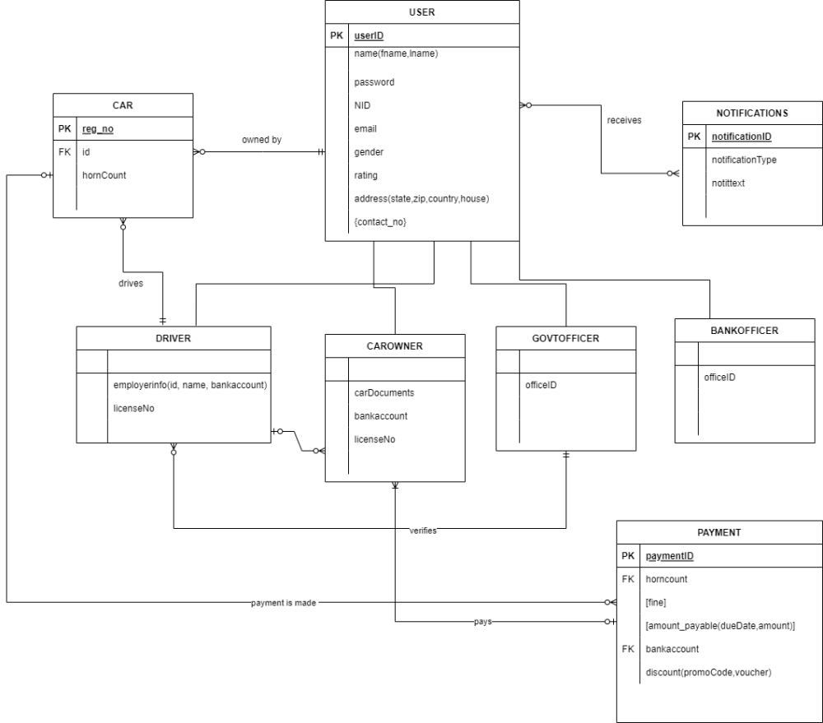

# 15. Logical Data Flow Diagram

***Diagram 0:***



***User Registration:***

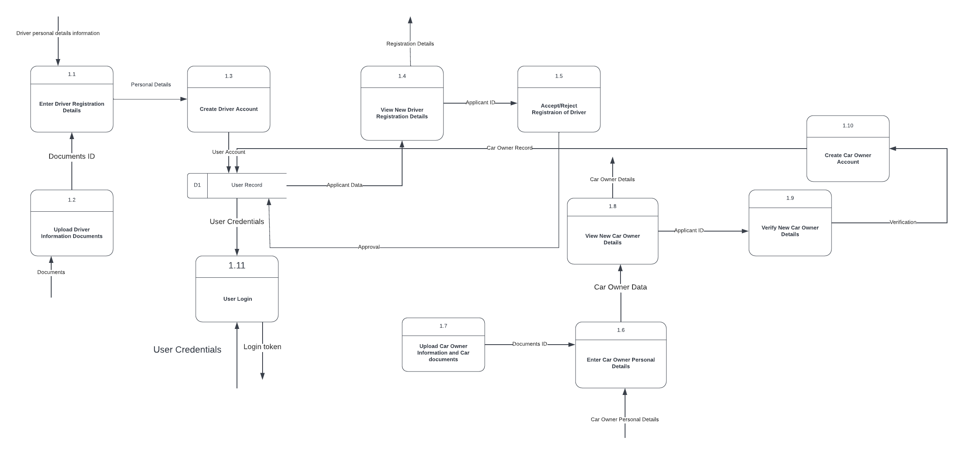

***Notification:***

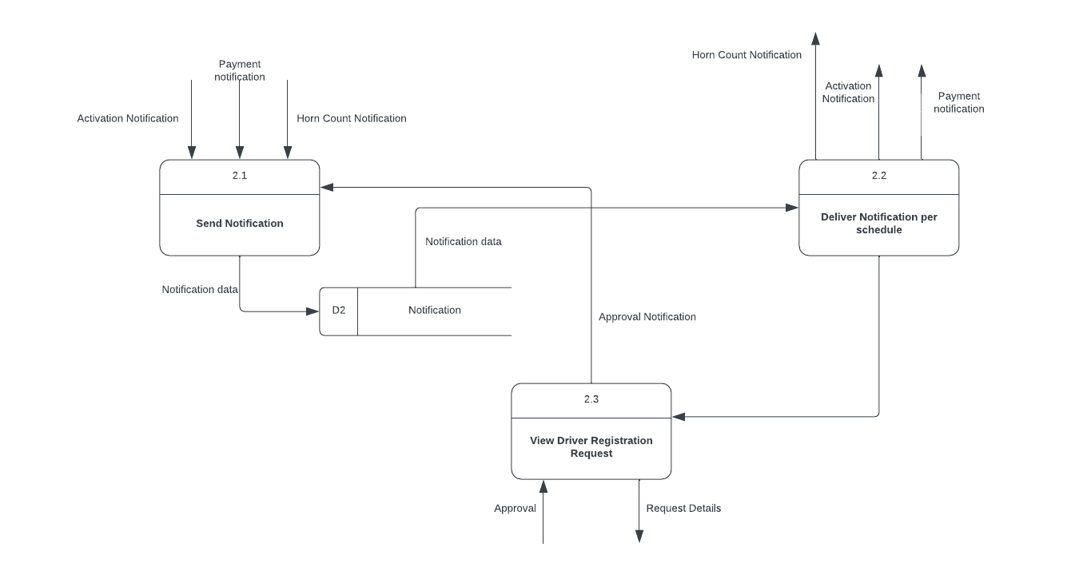

***Payment:***

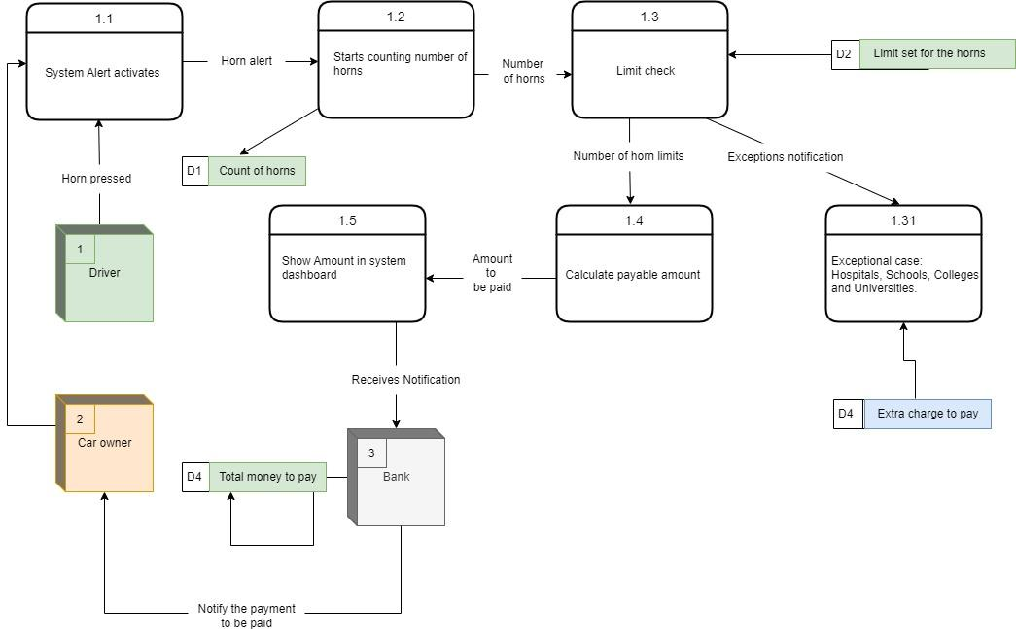

***Transfer of Ownership:***

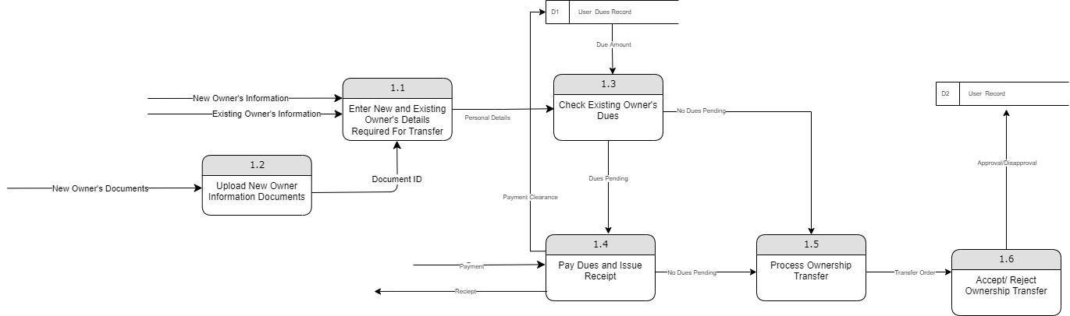

# 16. Physical Data Flow Diagram

***User Registration:***

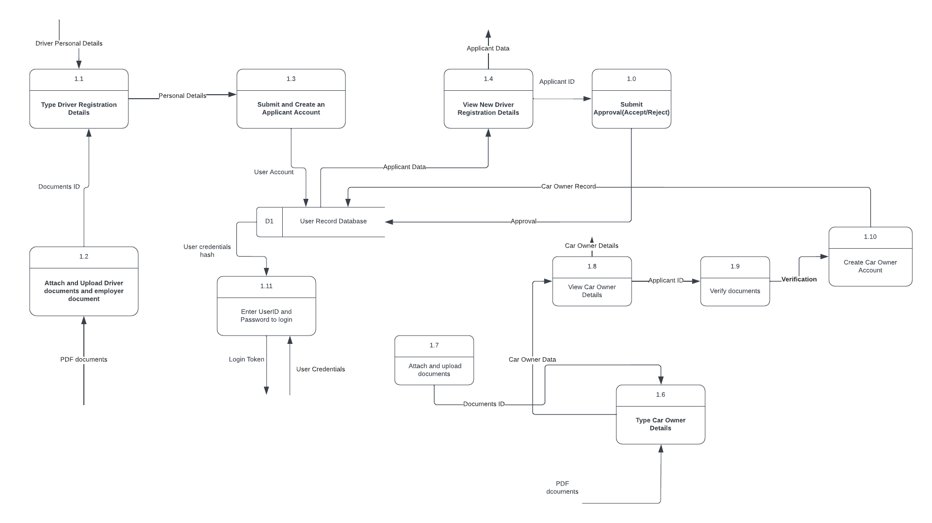

***Notification:***

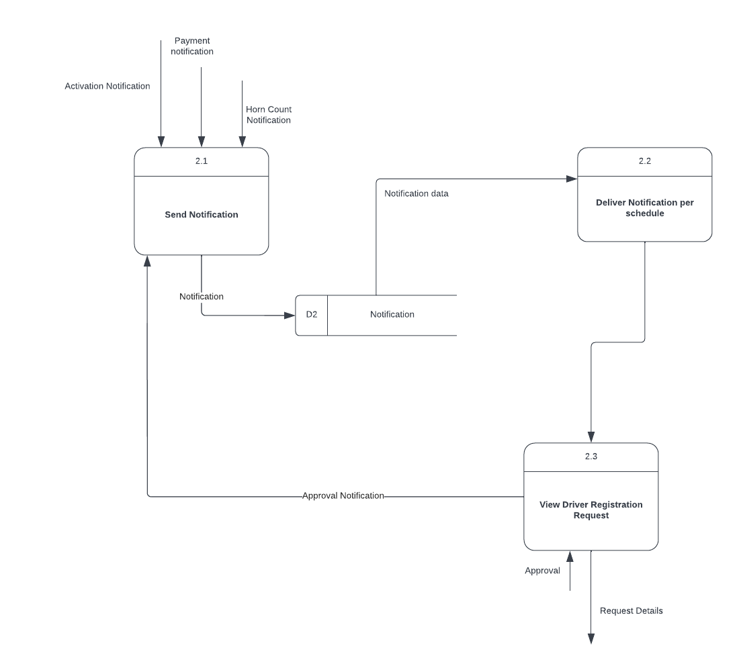

***Payment***

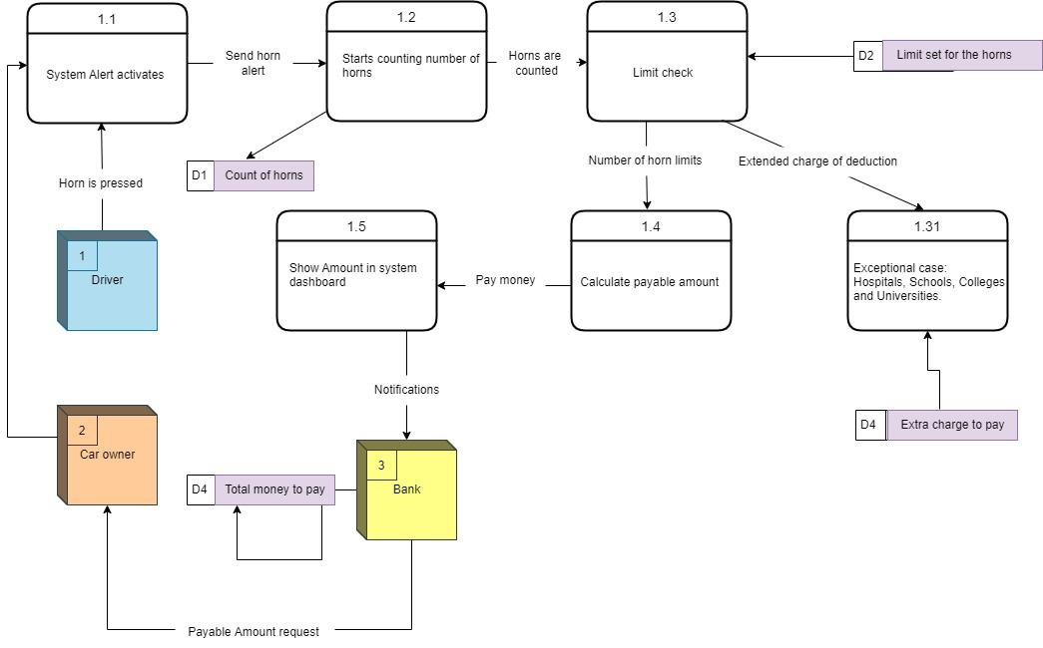

***Transfer of Ownership***

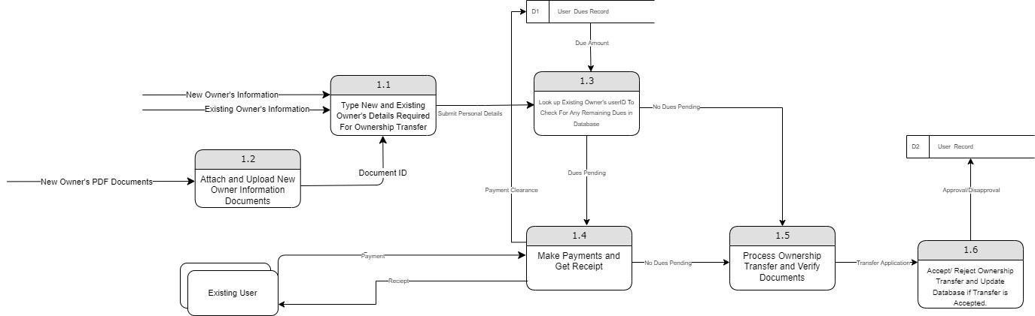

# 17. Activity Diagrams

***Activity: User Registration***

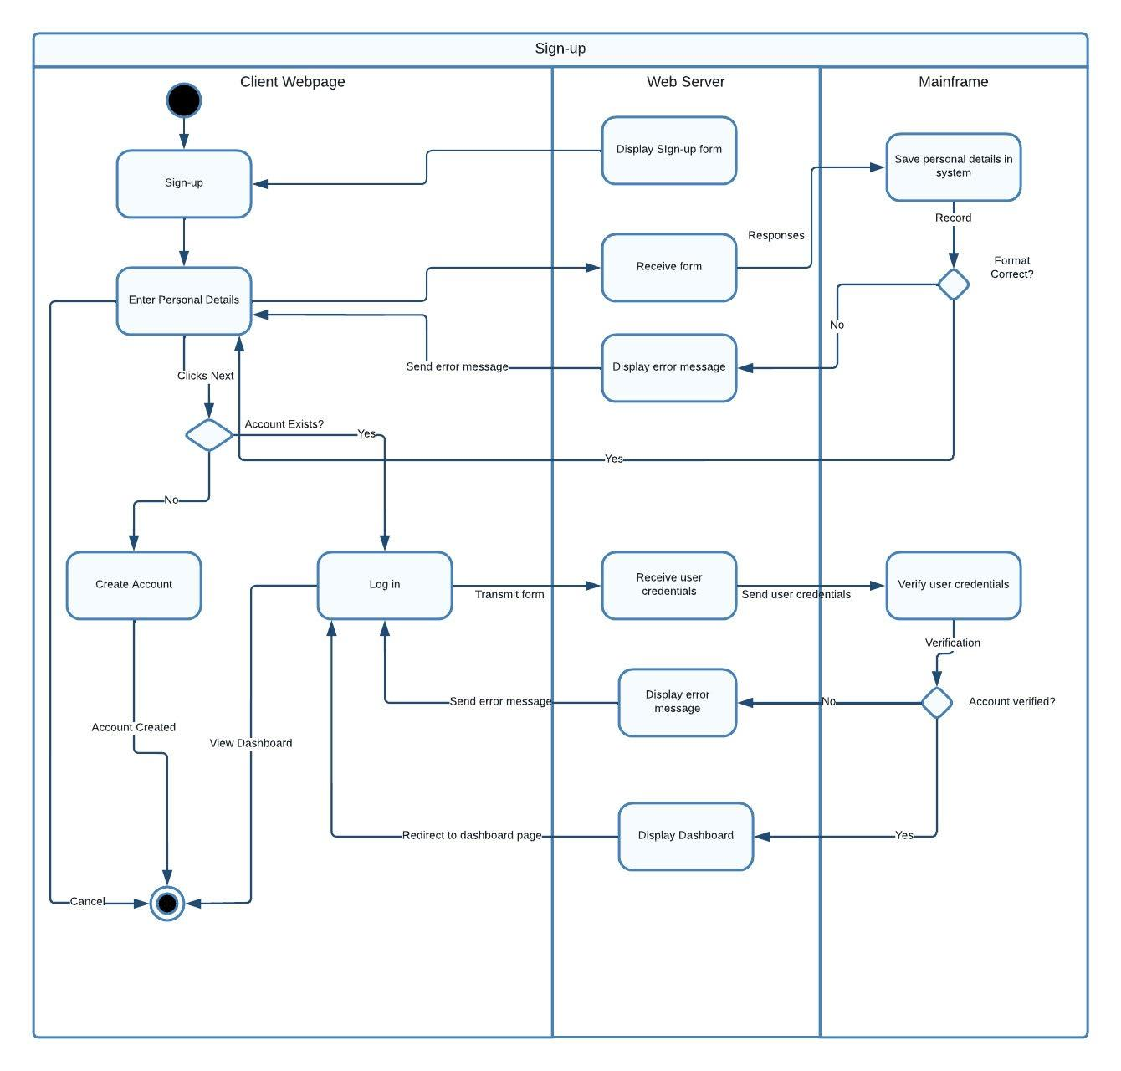

***Activity: Activation Notification***

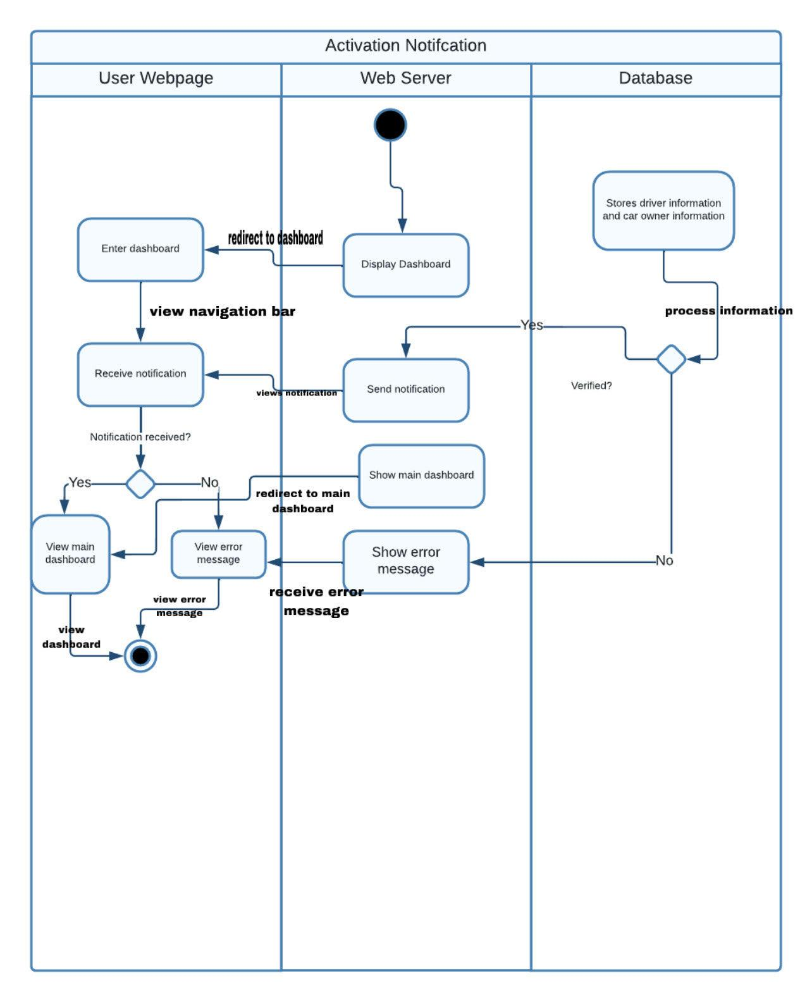

***Activity: Payment Notification***

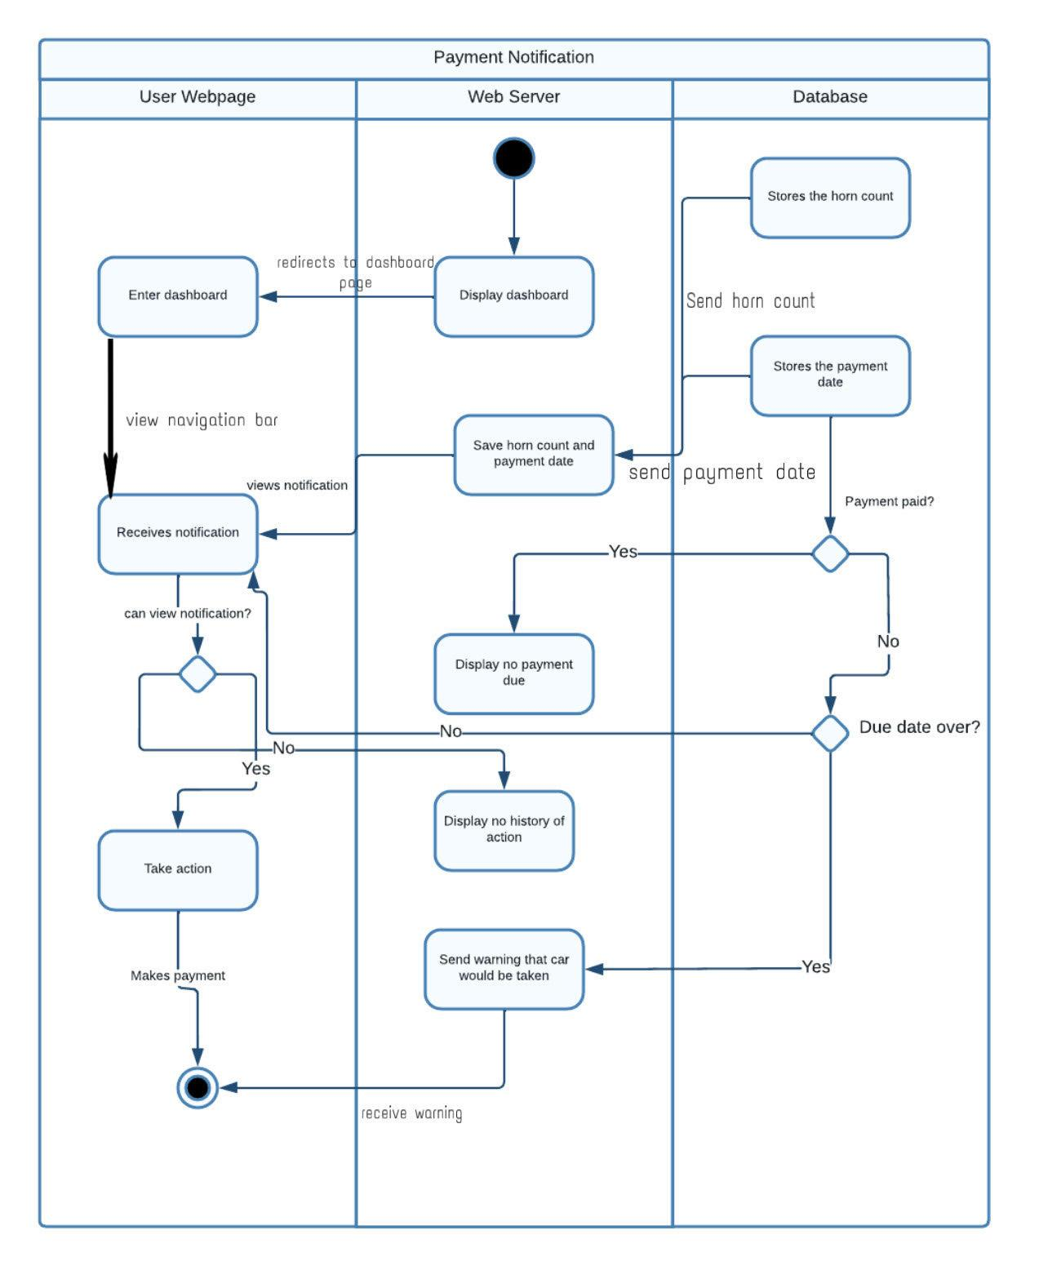

***Activity: Car Owner Registration***

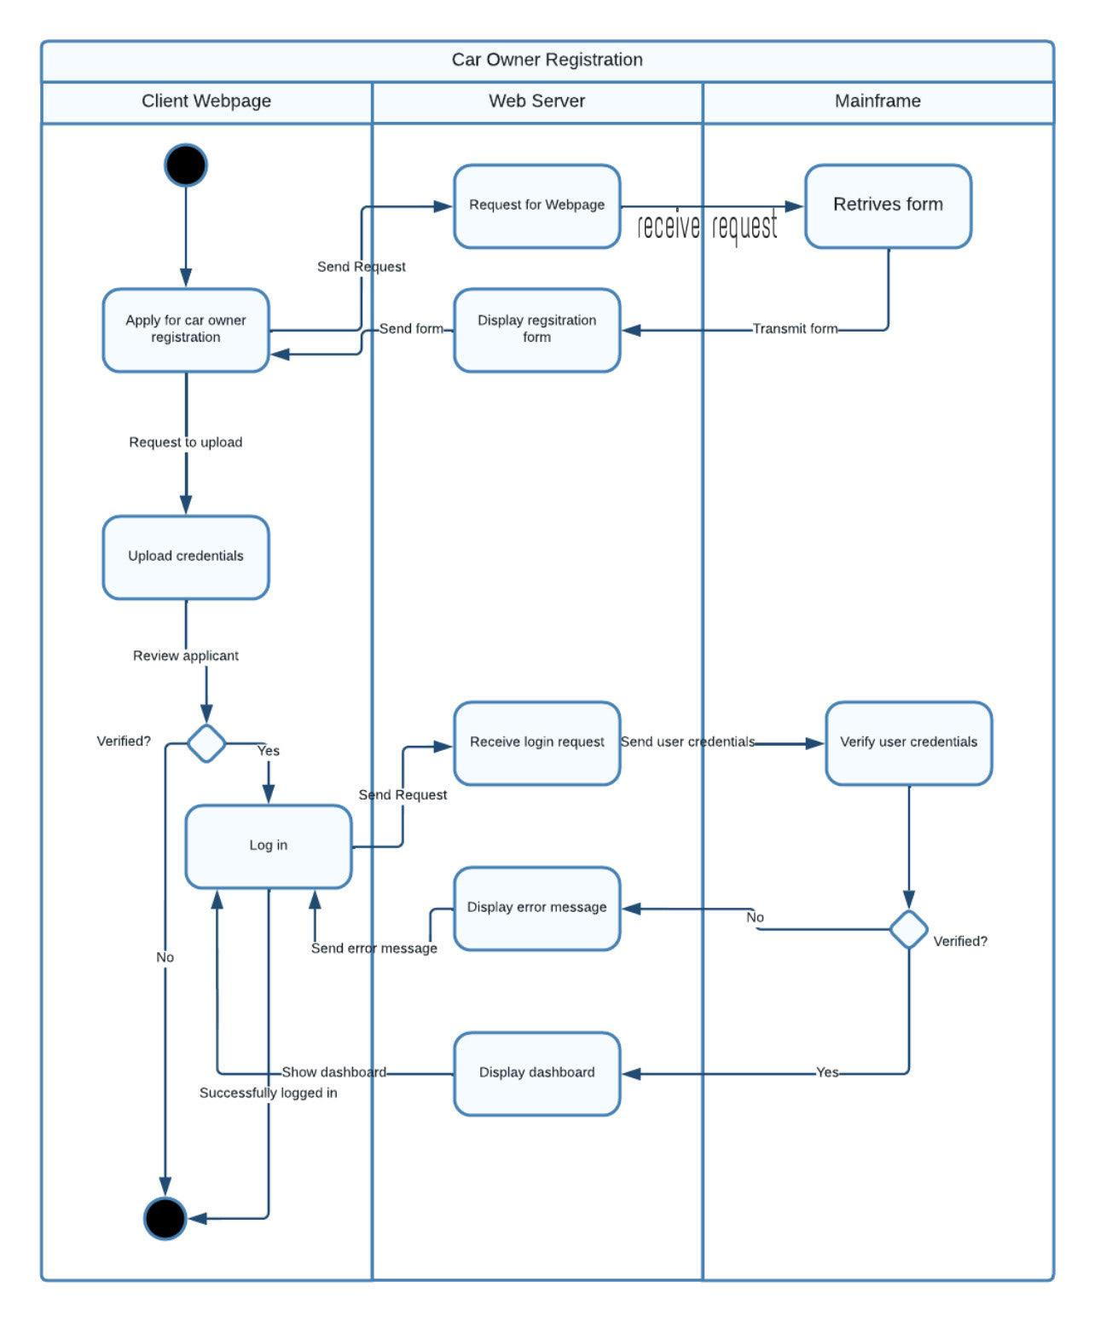

***Activity: Making payment***

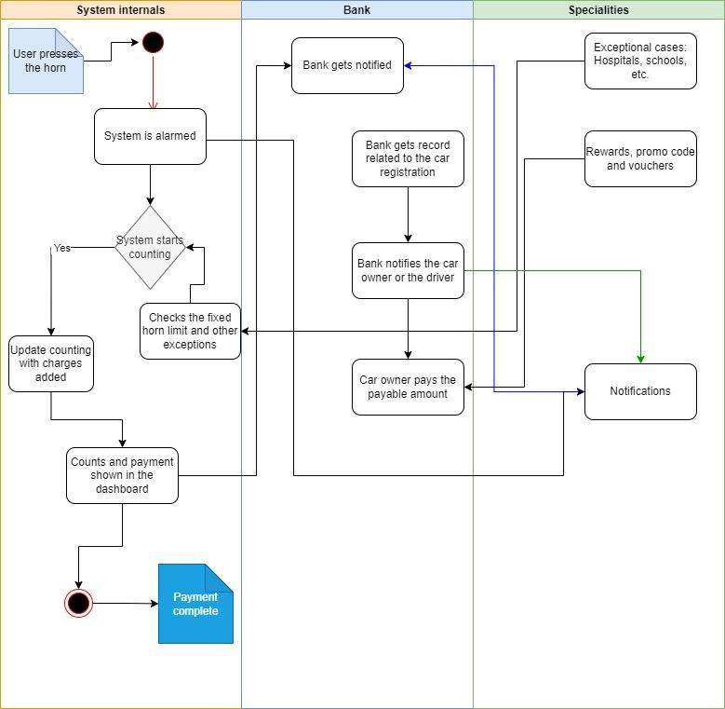

***Activity: Transfer of Ownership***

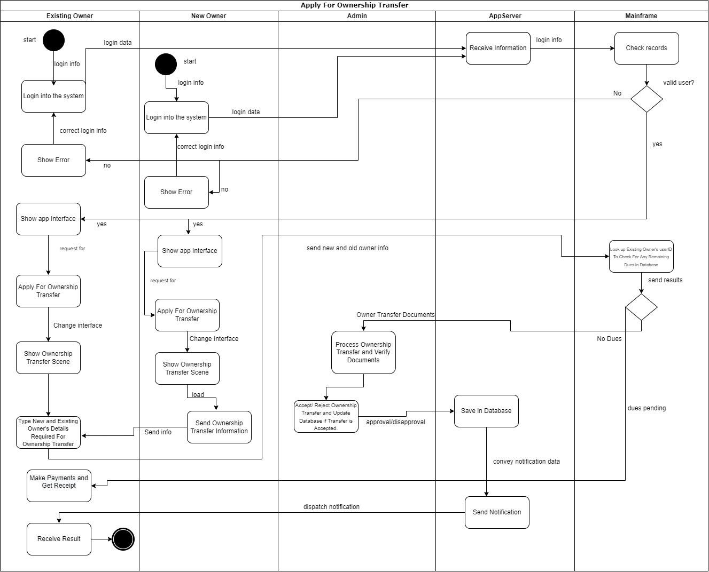

# 18. Sequence Diagrams

***User Sign-up***

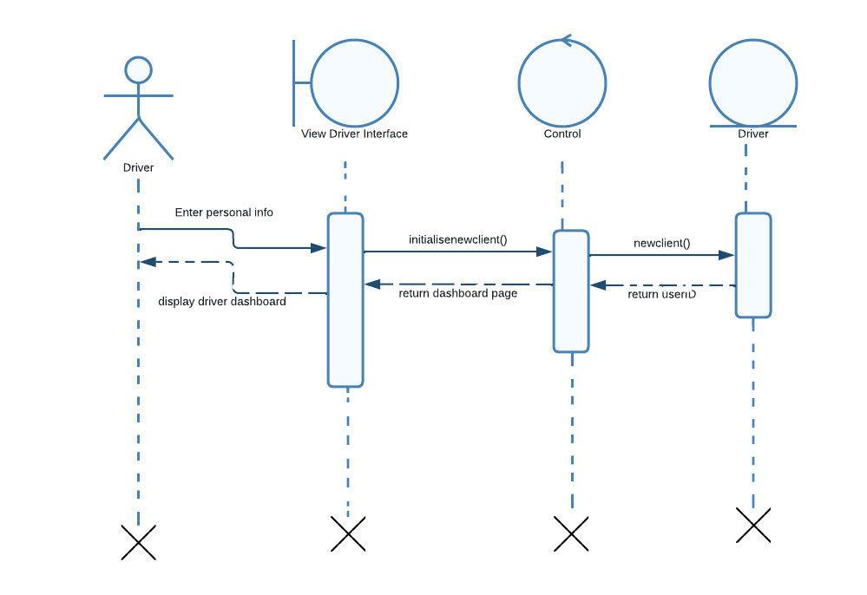

***Payment***

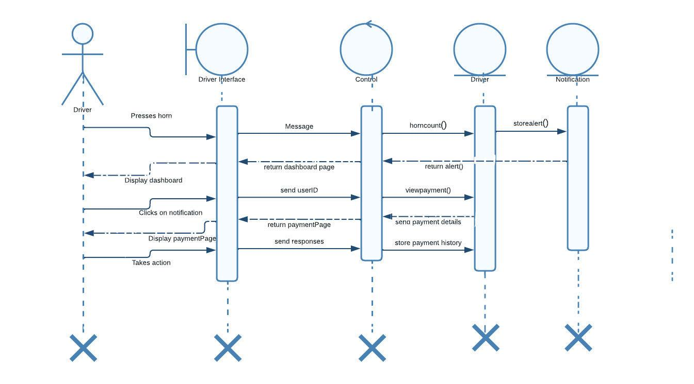

***Horn Counting***

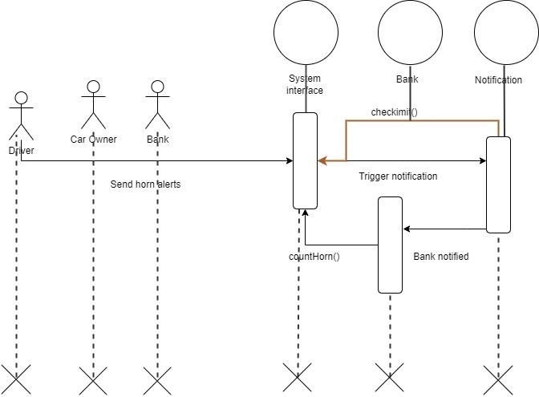

***Transfer of Ownership***

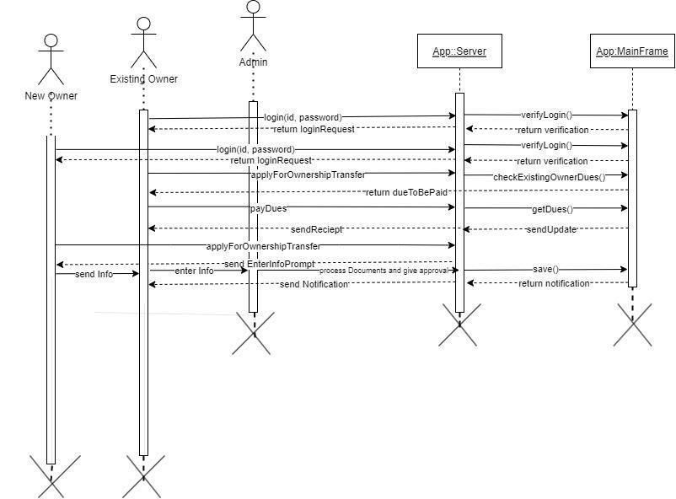

# 19. Communication Diagrams

***User registration***

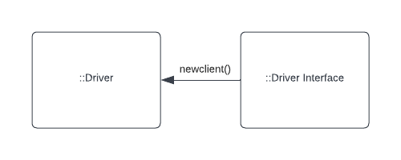

***Payment***

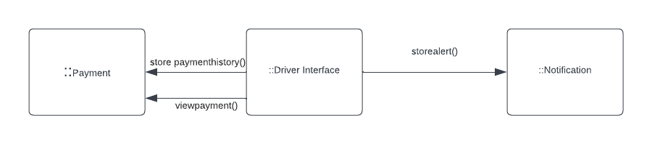

***Transfer of Ownership***

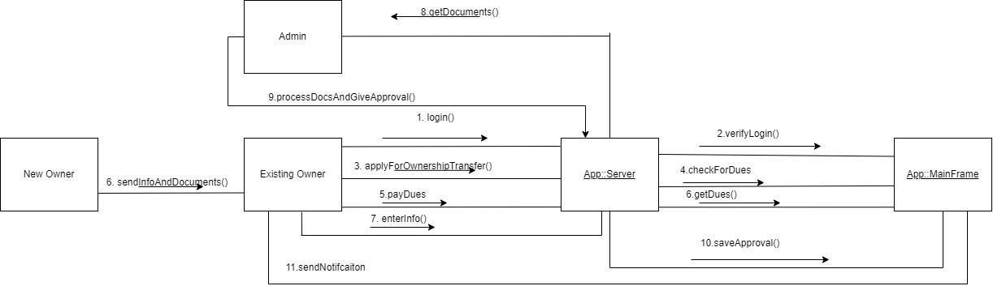

# 20. Class diagrams

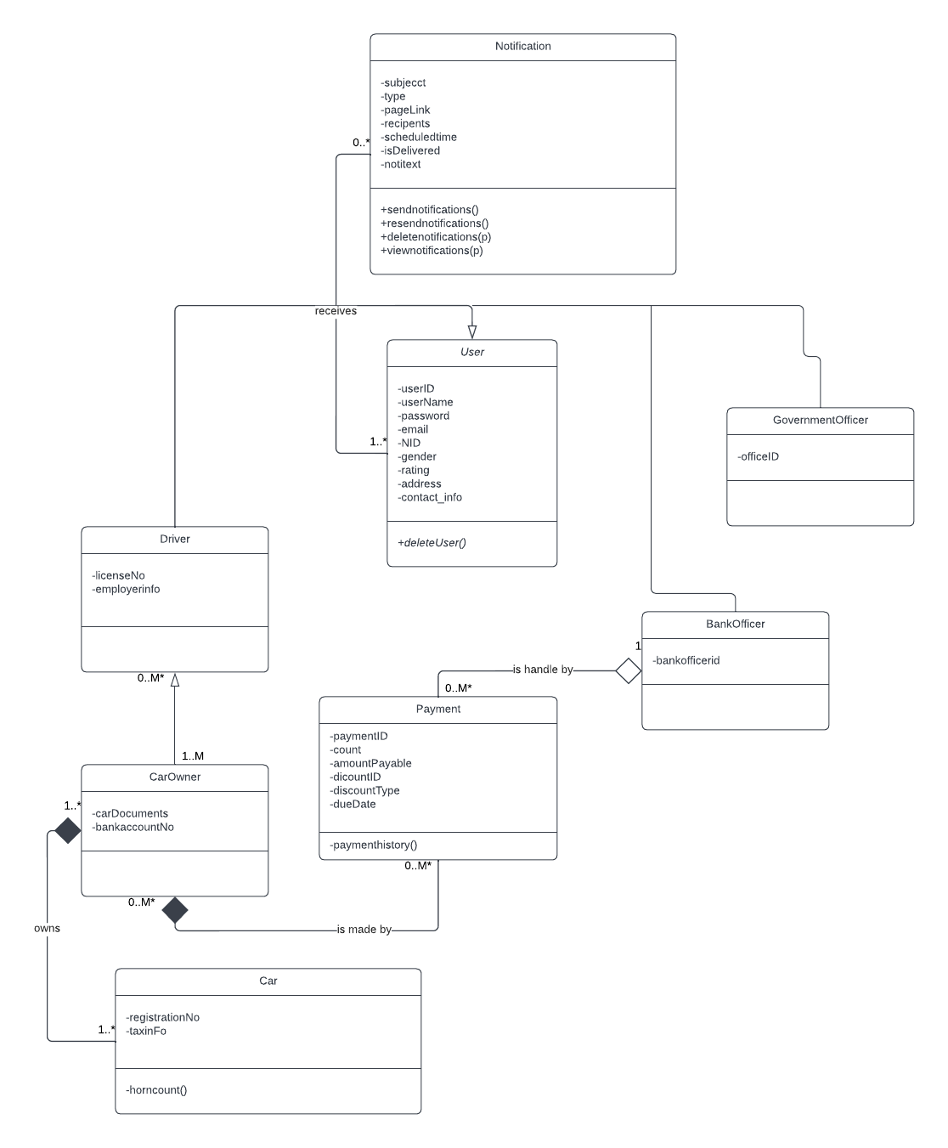

# 21. State-chart Diagrams

***User Registration***

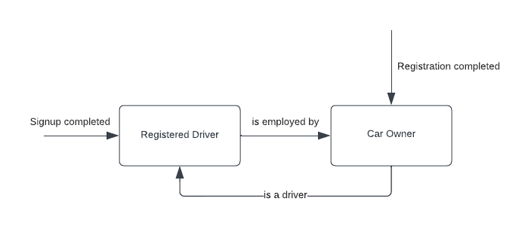

***Payment***

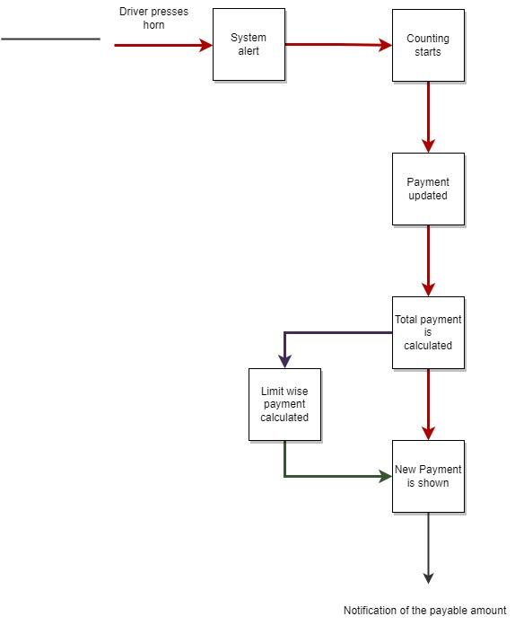

***Transfer of Ownership***

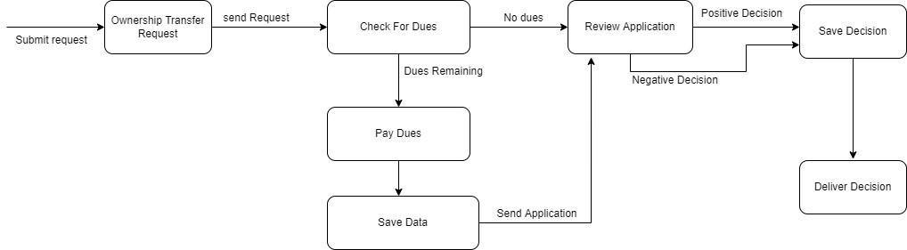

# 22. CRUD Matrix

***User Registration***

|  |  |  |  |  |  |
| --- | --- | --- | --- | --- | --- |
| **ACTIVITY** | **DRIVER** | **CAR OWNER** | **ADMIN** | **BANK OFFICER** | **GOVERNMENT OFFICER** |
| **Enter Driver Personal Details** | **U** |  |  |  |  |
| **Create Driver Account** | **C** |  |  |  |  |
| **Register Car Owner** | **U** |  |  |  |  |
| **User log in** | **R** | **R** | **R** | **R** | **R** |
| **Upload Car Documents** |  | **U** |  |  |  |
| **View Payment Details** | **R** | **R** |  | **R** |  |
| **View New Car Owner Registration** |  |  | **R** |  | **R** |
| **Accept/Reject Car Owner** |  |  | **U** |  | **U** |
| **Send Notification** | **C** |  |  | **CU** | **CU** |
| **Deliver Notification** | **RU** |  |  | **R** | **R** |
| **Make Payment** |  | **CU** |  | **R** | **R** |

***Payment***

**Activity User Bank Payment Notification**

|  |  |  |  |  |
| --- | --- | --- | --- | --- |
| User registration | C |  |  | C |
| User logon | R |  |  | R |
| Provide personal info | CU | R |  | RU |
| Provide bank details | U | RU |  | U |
| Read guidelines | R | R |  |  |
| Pay charge | U | RUD | U | R |
| Check rewards | R | RUD | CRUD | CR |
| Get notification | R | U | D | C |

***Transfer of Ownership***

|  |  |  |  |  |
| --- | --- | --- | --- | --- |
| **Activity** | **Existing**  **Owner** | **New Owner** | **Admin** | **Driver** |
| Register | **C** | **C** |  |  |
| Login | **R** | **R** |  |  |
| Edit profile |  | **U** | **R** |  |
| Apply For  Ownership  Transfer | **U** | **U** | **R** |  |
| Horn Notification | R | R | **RU** | **R** |
| Ownership Notification | **R** | R |  |  |

# Section 5:

# 23. Structure English pseudo code for the system

***User Sign-up***

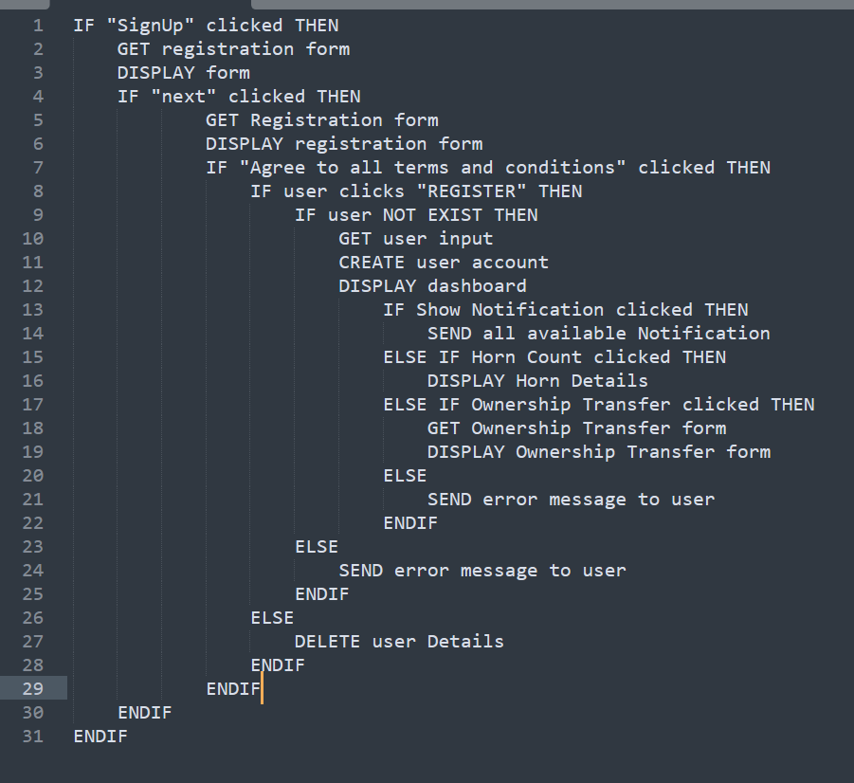

***Notification System***

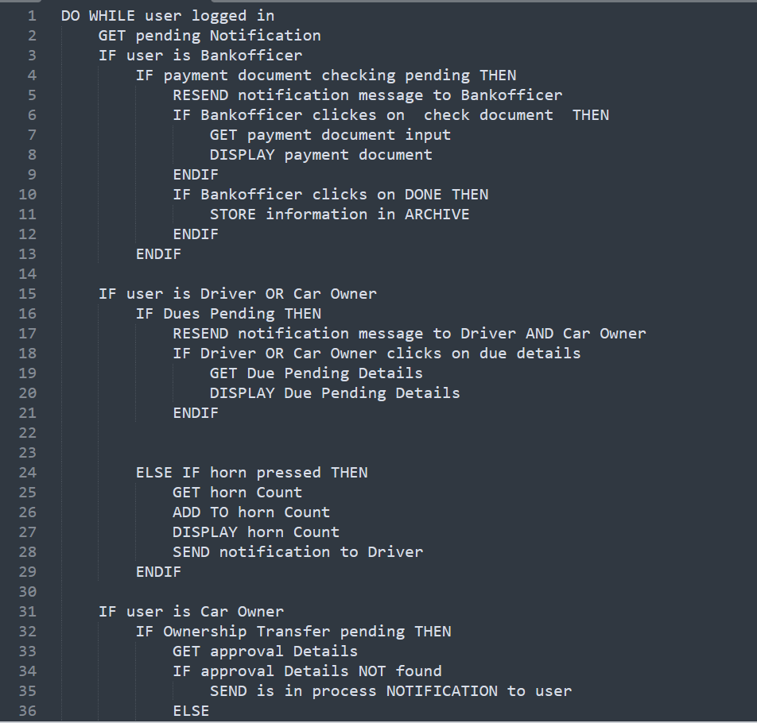

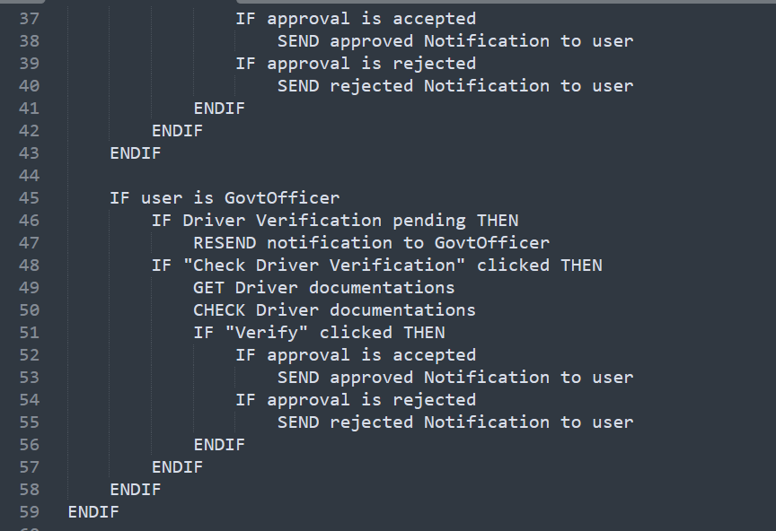

***Horn Count***

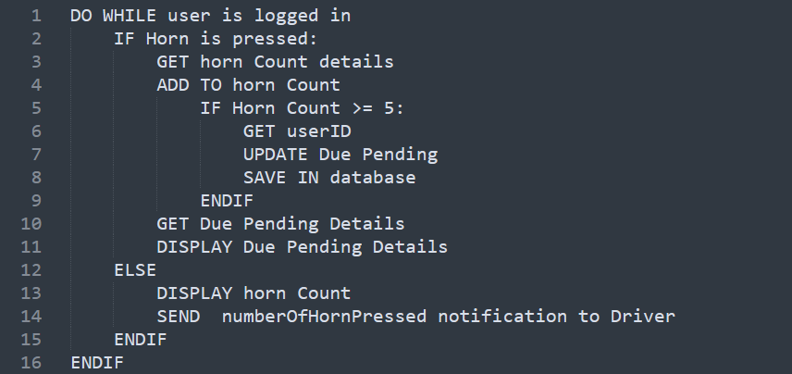

# 25. Prototype the user interface

***User Sign-up***

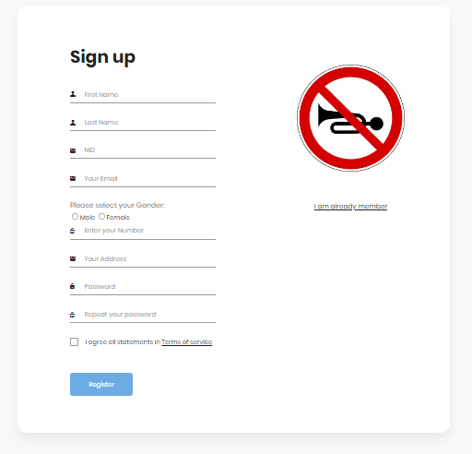

***User Login***

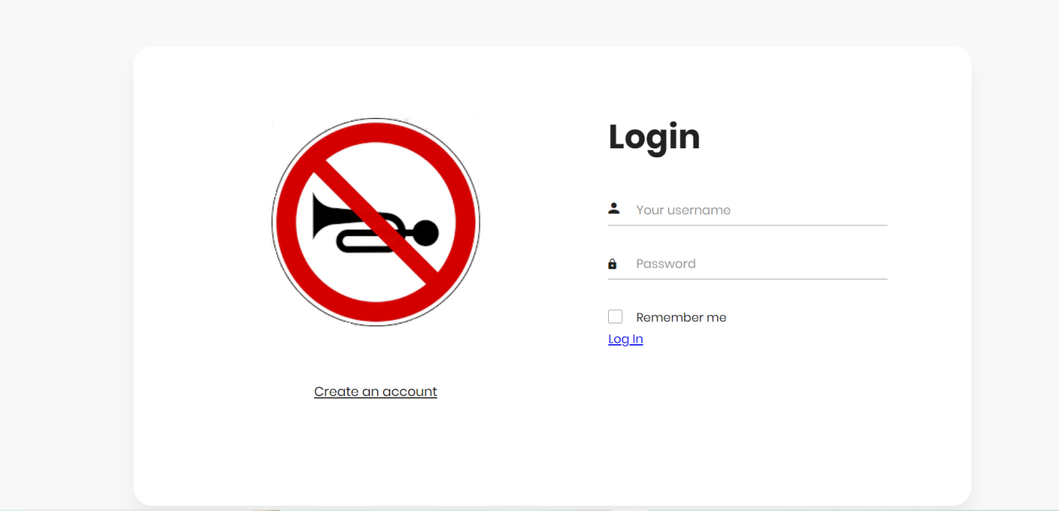

***User Dashboard***

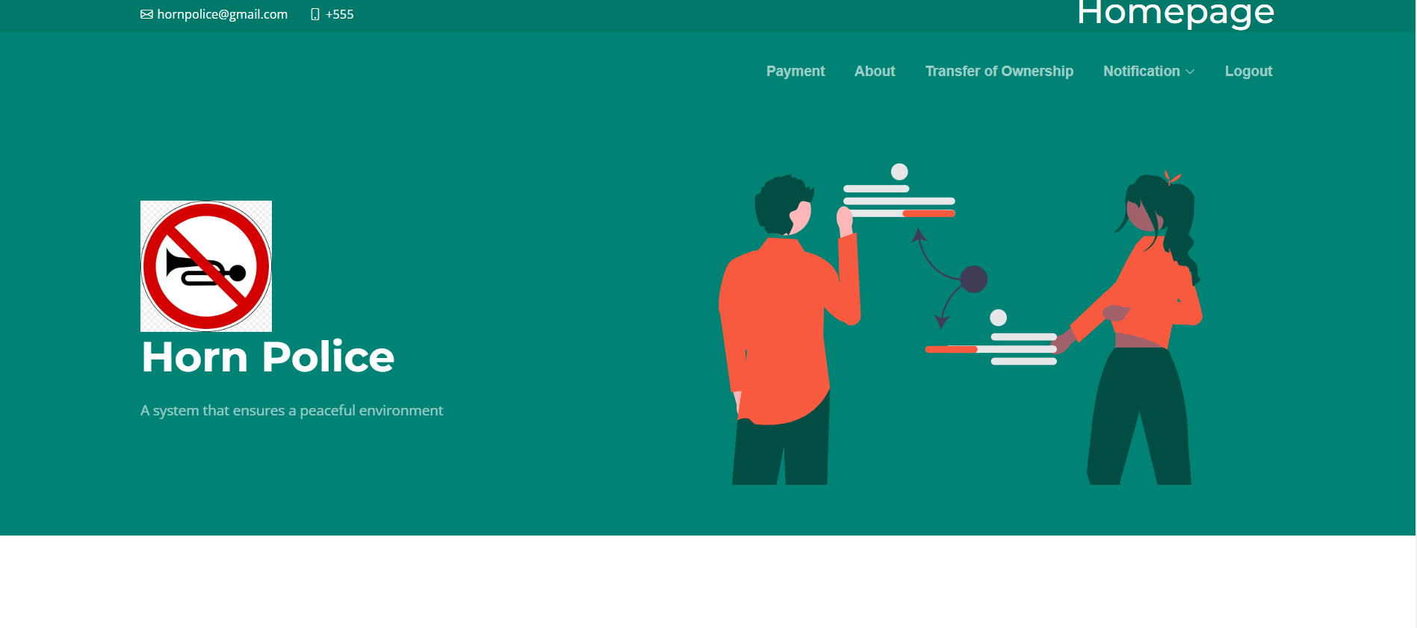

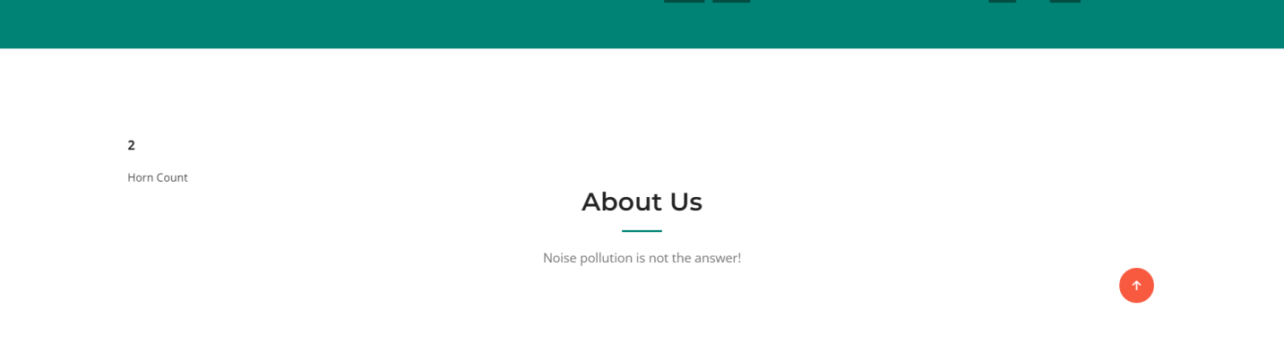

***User Navigation Bar***

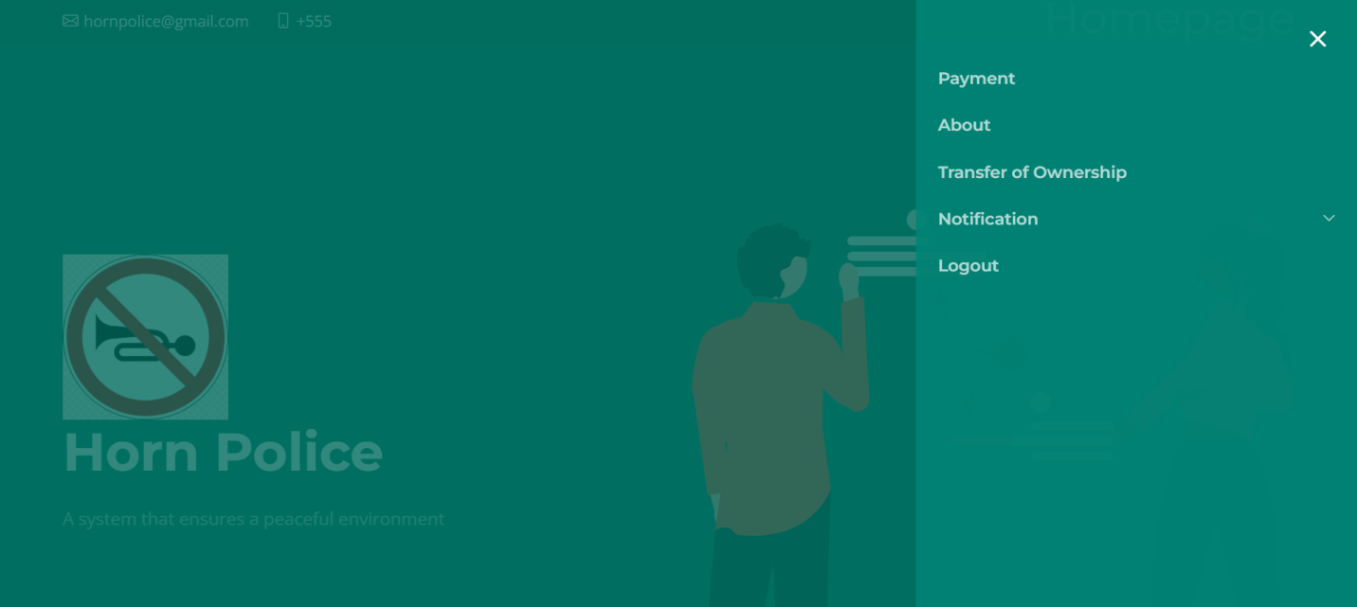

***User Payment Information Page***

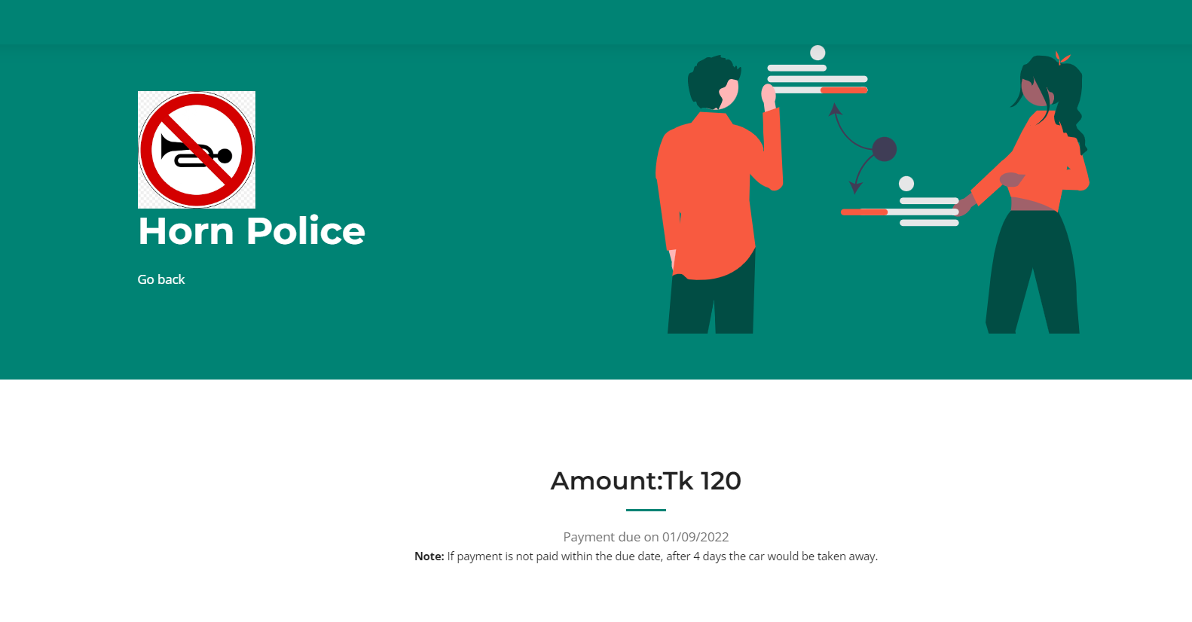

***Transfer of Ownership Page***

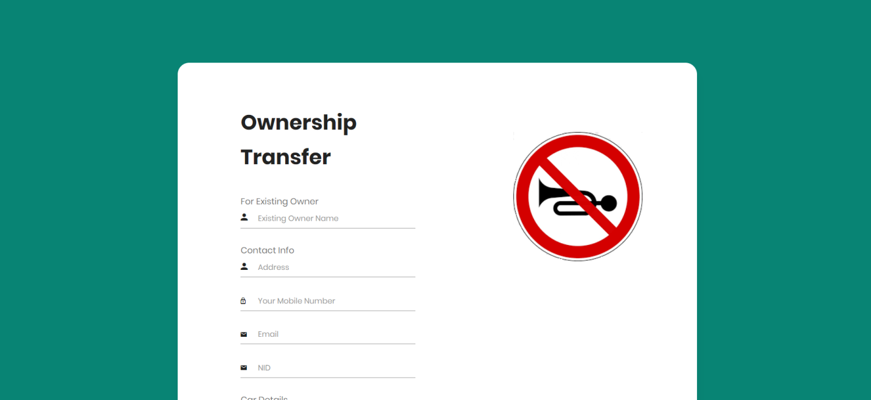





***User Notification***

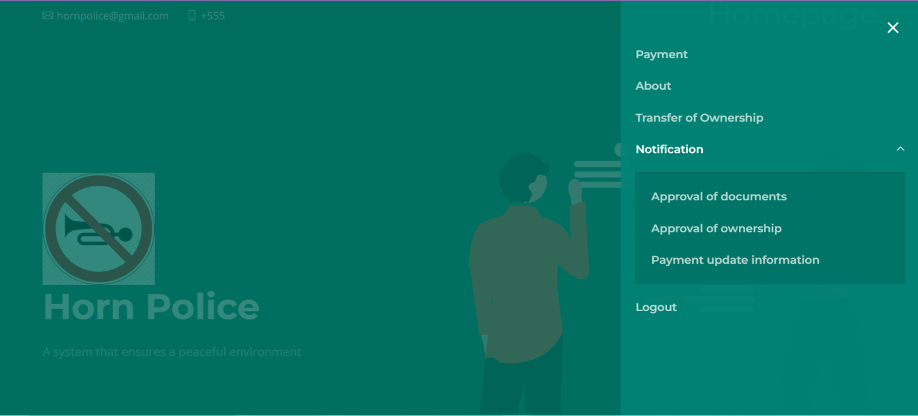

***User Payment Update Information Notification***

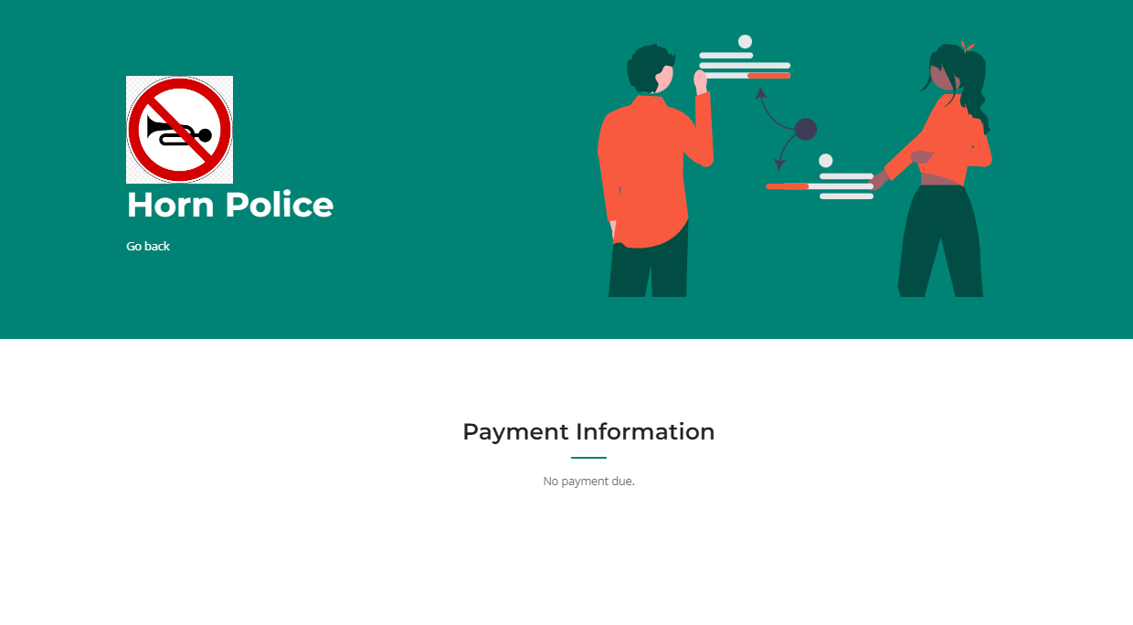

***Approval of Documents Information***

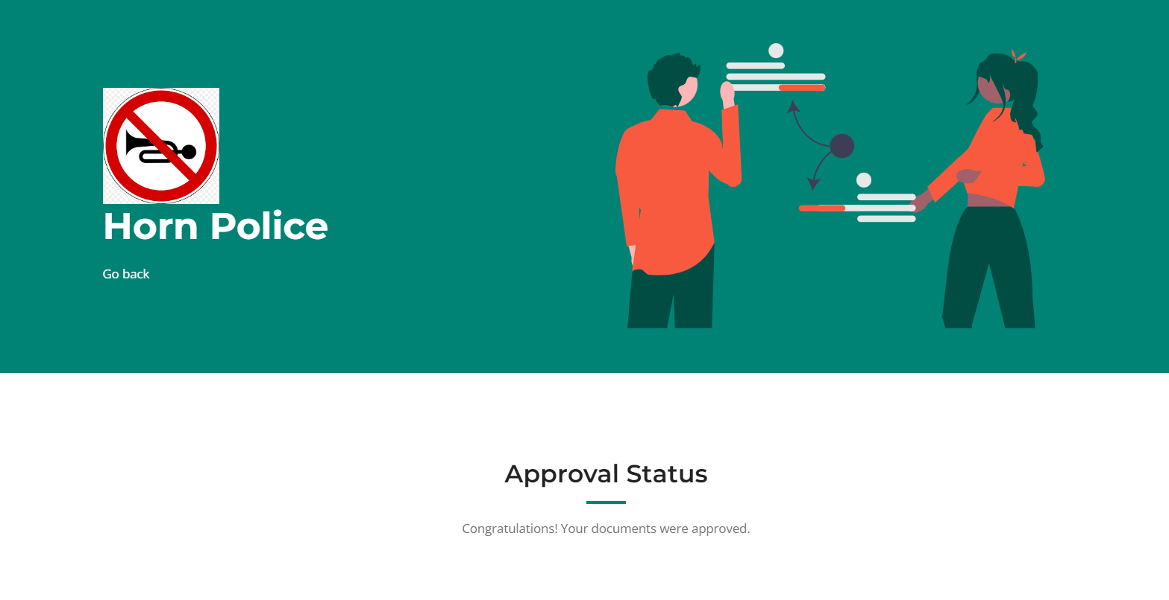

***Approval of ownership transfer notification***

